

Capstone Project Report
Report 1 – Project Introduction

– Can Tho, August 2023 –

Contents
I. Project Report 5
II. Project Introduction 5
1. Overview 5
1.1 Project Information 5
1.2 Project Team 5
a. Supervisor 5
b. Team Members 6
2. Product Background 6
2.1 AI System 6
2.1.1 Machine Learning 6
2.1.2 Deep Learning 7
2.1.3 Python 3.10 8
2.1.4 Cloudinary 8
2.1.5 Yolov8 9
2.2 Web-based application 9
2.2.1 SQL Server 9
2.2.2 Asp .Net Core 6.0 10
2.2.3 JavaScript 11
2.2.4 CSS 11
2.2.5 React 18.2.0 12
2.2.6 Linux 13
2.2.7 NGINX 13
2.2.8 Google Cloud 14
2.3 Android application 14
2.3.1 Axios 1.4.0 14
2.3.3 React Native 0.72 15
3. Existing Systems 15
3.1 Doctor 15
3.2 PureSkin Laser Clinic 16
3.3 MedPro 17
3.4 VietSkin 17
4. Business Opportunity 18
5. Software Product Vision 19
6. Project Scope & Limitations 19
6.1 Major Features 19
6.2 Limitations & Exclusions 19

Project Report
# | Task | Member | Date | Status
1 | Overview, Product Background | TinTT | 02/5/2023 | Completed
2 | Product Background | KhangLTV | 04/5/2023 | Completed
3 | Product Background | TinTT | 05/5/2023 | Completed
4 | Existing Systems | KhangLTV | 06/5/2023 | Completed
5 | Existing Systems | TinTT | 06/5/2023 | Completed
6 | Business Opportunity, Software Product Vision | HieuTH | 07/5/2023 | Completed
7 | Major Features | KhaTM | 08/5/2023 | Completed
8 | Limitations & Exclusions | HungLH | 09/5/2023 | Completed

II. Project Introduction

1. Overview

1.1 Project Information
- Project name: Dermatology Clinic Management System
- Project code: DCMS
- Group name: HKT Group
- Software type: Software type: Web-based Application, Application Android.

1.2 Project Team

a. Supervisor
Full Name | Email | Phone Number | Title
Quách Luyl Đa | DaQL@fe.edu.vn | 0976703075 | Lecturer

b. Team Members
Full Name | Email | Mobile | Role
Lê Hoàng Hưng | hunglhce150320@fpt.edu.vn | 0387440961 | Leader
Trần Minh Kha | Khatmce150695@fpt.edu.vn | 0869392769 | Member
Lương Tống Vĩnh Khang | Khangltvce150092@fpt.edu.vn | 0779801971 | Member
Trương Hoàng Hiếu | Hieuthce150749@fpt.edu.vn | 0868852129 | Member
Trương Trung Tín | Tinttce150623@fpt.edu.vn | 0838859777 | Member

Product Background
In traditional dermatology clinics, managing patient records, appointments, treatments, and billing can be a time-consuming and error-prone task. DCMS was developed to address these challenges and provide a centralized platform for dermatologists, medical staff, and administrators to better manage their clinic operations and deliver top-notch patient services.
Skinsense (Dermatology clinic management system) is a comprehensive web-based application and android application designed for dermatology clinics to manage patient information, appointments, medical records management, billing, and other administrative tasks efficiently. The system is specifically developed to enhance the workflow of dermatologists and their staff members while providing quality patient care. The primary goal of DCMS is to streamline the management of the clinic's daily operations by automating various processes such as appointment scheduling, patient registration, treatment plan creation, and medical billing. The system enables dermatologists to access patient records and treatment histories easily, facilitating informed decision-making during consultations and follow-up visits. Additionally, the application is built on the web using C# (.Net framework), the machine learning model is built using Python and YOLOv8, and the data is saved on MySQL.

2.1 AI System

2.1.1 Machine Learning
Machine learning is a branch of artificial intelligence (AI) that focuses on developing algorithms and techniques that enable computers to learn and make predictions or decisions without being explicitly programmed. It involves the construction of mathematical models and algorithms that can analyse and interpret complex data, identify patterns, and make predictions or take actions based on the learned patterns. Here are example when applying AI to life:
- Scene segmentation can help identify and track objects within an image or video. This has practical applications in areas like surveillance, autonomous vehicles, and augmented reality. For example, it can assist in identifying and tracking pedestrians, vehicles, or other objects of interest in real time.
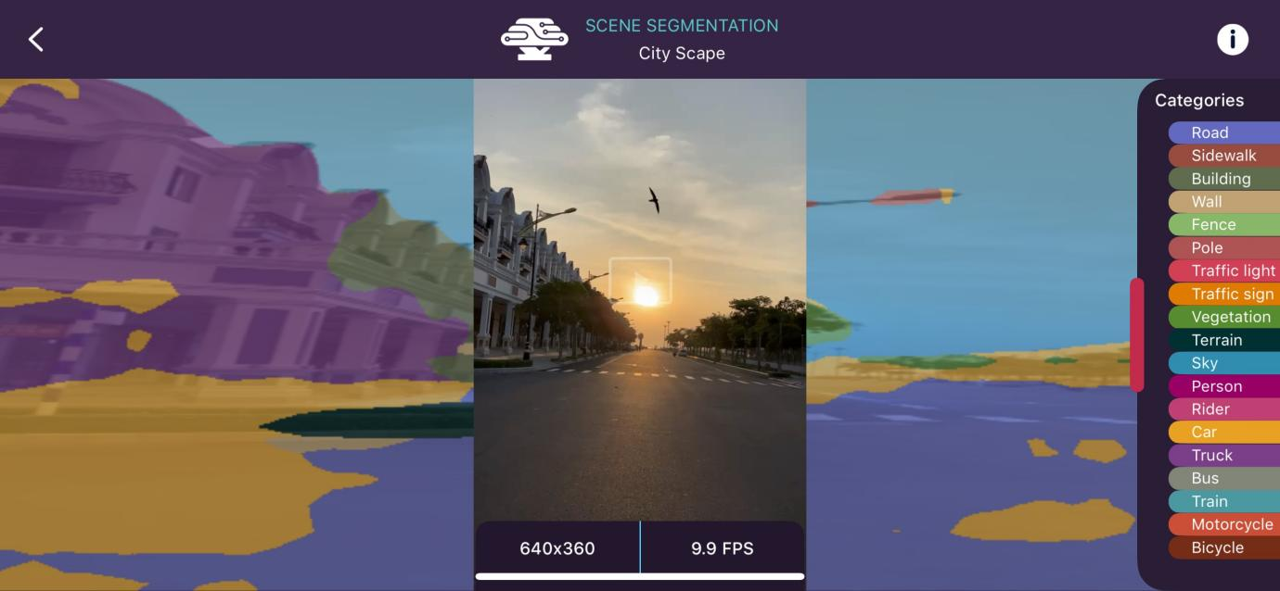
Figure 1. Boneyse application use for scene segmentation
Source: https://beta.bonseyes.com/

2.1.2 Deep Learning
Deep learning is a sub field of machine learning that involves the use of artificial neural networks to model and solve complex problems. It is inspired by the structure and function of the human brain, where neural networks process information and learn from it. Deep learning algorithms are designed to automatically learn and represent patterns and features from large amounts of data.
Deep learning can be leveraged in the Dermatology clinic management system (DCMS) to enhance various aspects of the system and improve the overall efficiency and accuracy of dermatology clinics.
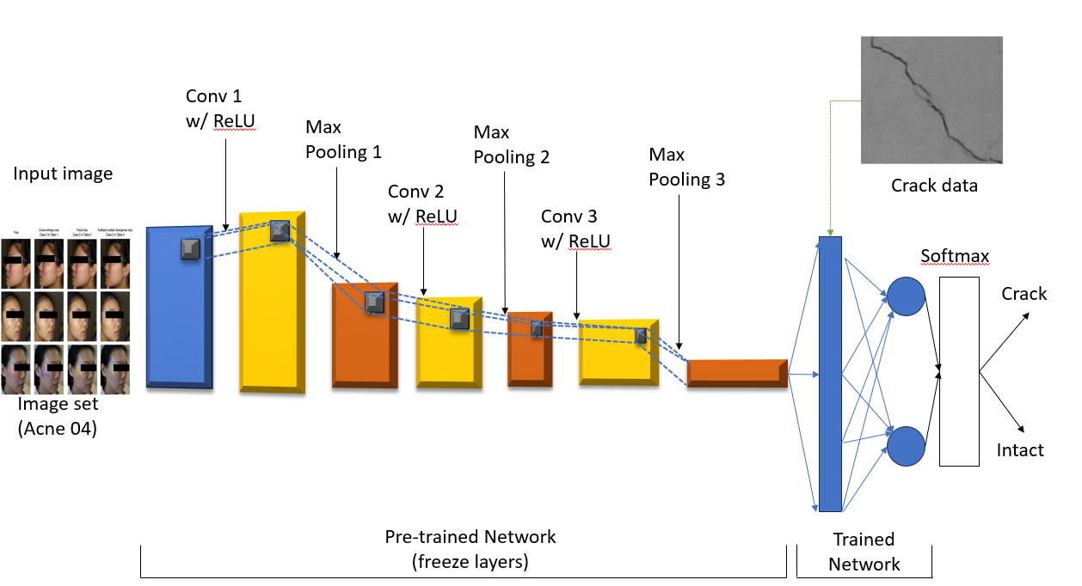
Figure 2. Schematic of the deep learning architecture
Source: https://www.researchgate.net/figure/Schematic-of-the-deep-learning-architecture_fig4_325663483

2.1.3 Python 3.10

Figure 3. Python
Source: https://vtiacademy.edu.vn/upload/images/python-co-ban-1.jpg
Python is a robust and user-friendly programming language, known for its ease of learning. It boasts efficient high-level data structures and follows a straightforward yet impact approach to object-oriented programming. With its elegant syntax, dynamic typing, and interpreted nature, Python proves to be an excellent choice for scripting and rapid application development across diverse fields on virtually any platform.
Pythons can play a significant role in the dermatology clinic management system (DCMS) AI System, contributing its strengths to various aspects of the application. Python's data manipulation libraries can manipulate data to produce accurate results for patients. Applying Python's Machine Learning and AI Algorithms, to be able to build and train is an AI model used to process images, classify acne and give the best diagnosis. Next, using python’s OpenCV library, a powerful tool for image processing and computer vision tasks. It is used to analyze dermatology images, identify patterns, and assist in diagnosing skin conditions.

2.1.4 Cloudinary

Figure 4. Cloudinary
Source: https://cloudinary.com/
Cloudinary is a comprehensive cloud-based media management platform that provides developers and businesses with powerful tools for managing, optimizing, and delivering media assets such as images, videos, and other digital content. It was founded in 2012 to address the challenges developers faced in handling media efficiently and seamlessly across various digital channels.
Cloudinary can act as a secure and scalable cloud-based repository for storing and managing medical images, such as skin lesions, dermatological scans, and patient photos. These images can be easily uploaded, organized, and accessed by authorized healthcare professionals.

2.1.5 Yolov8
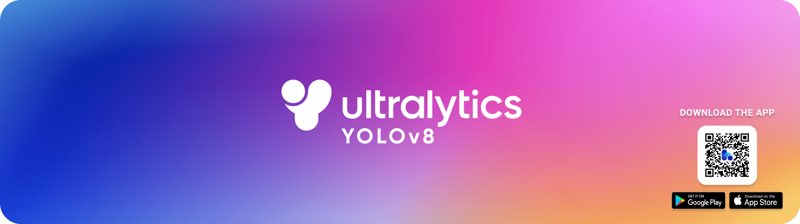
Figure 5. Ultralytics YOLOv8
Source: https://github.com/ultralytics/ultralytics
Ultralytics YOLOv8 stands at the forefront of modern technology, representing the state-of-the-art (SOTA) in the realm of computer vision models. It builds upon the accomplishments of its YOLO predecessors and elevates them to new heights by introducing innovative features and enhancements. The primary goal of YOLOv8 is to achieve exceptional speed, accuracy, and user-friendliness, making it an ideal solution for various tasks such as object detection and tracking, instance segmentation, image classification, and pose estimation. Its remarkable capabilities empower researchers and practitioners to address a wide range of challenges in the field of computer vision with ease and efficiency.
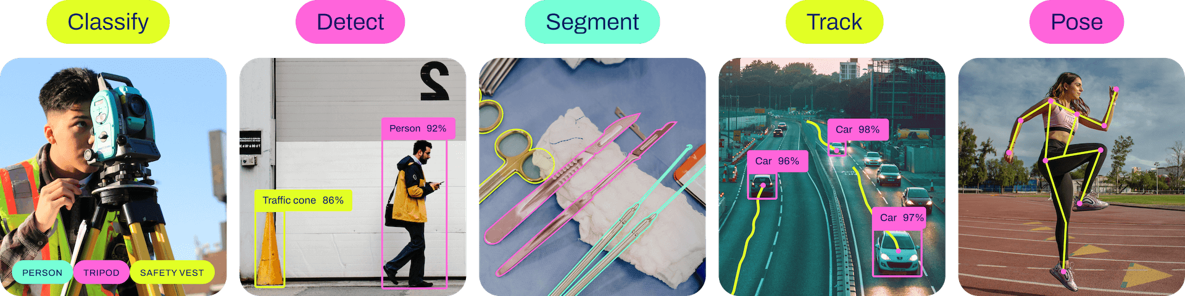
Figure 6. Model Yolov8
Source: https://github.com/ultralytics/ultralytics

2.2 Web-based application

2.2.1 SQL Server

Figure 7. SQL server
Source: https://maychusaigon.vn/wp-content/uploads/2022/09/dinh-nghia-sql-server-la-gi-maychusaigon.jpg
SQL Server is a relational database management system (RDBMS) developed by Microsoft. It is used to store, retrieve, and manage structured data, primarily in the form of tables, rows, and columns. SQL Server supports the SQL (Structured Query Language) for interacting with the database, making it easy to perform various database operations such as querying, inserting, updating, and deleting data.
Integrating SQL Server into the dermatology clinic management system (DCMS) can provide a robust and scalable database solution for managing various aspects of the clinic's operations and patient data. SQL Server’s features and performance make it suitable for handling the data needs of a dermatology clinic efficiently.

2.2.2 Asp .Net Core 6.0

Figure 8. Asp .Net Core
Source: https://upload.wikimedia.org/wikipedia/commons/e/ee/.NET_Core_Logo.svg
ASP.NET Core is a revolutionary version of ASP.NET, meticulously crafted by Microsoft. This open-source framework empowers developers to create dynamic web applications, capable of running seamlessly on Windows, Mac, or Linux environments. One of its remarkable features is its versatility to operate on both .NET Core and the traditional .NET Framework (versions 4. x).
This cutting-edge platform represents a complete re-imagining of its predecessor, bearing the initial name of ASP.NET 5 before being re-branded as ASP.NET Core 1.0. Its adaptability and performance make it a cross-platform marvel, facilitating the development of contemporary, cloud-based, and internet-connected applications that keep pacing with the demands of the modern world.
ASP.NET Core 6.0 can be a valuable technology for developing the dermatology clinic management system (DCMS). As the latest version of ASP.NET Core, it brings numerous improvements and features that can enhance the efficiency, performance, and security of the application.

2.2.3 JavaScript

Figure 9. JavaSript
Source: https://www.flaticon.com/free-icon/js_5968292
JavaScript stands as the dominant programming language empowering the creation of web pages and web applications. As an interpreted language, it adheres to the ECMAScript standard. It boasts a high-level nature, usually undergoing just-in-time compilation and exhibits a multi-paradigm approach. With its curly-bracket syntax, dynamic typing, prototype-based object orientation, and first-class functions, JavaScript proves to be a versatile and indispensable tool for developers on the web development landscape.
Incorporating JavaScript into the dermatology clinic management system (DCMS) offers a multitude of advantages. As a foundational language for web development, JavaScript plays a pivotal role in creating dynamic and interactive user interfaces.

2.2.4 CSS

Figure 10. Cascading Style Sheets
Source: https://upload.wikimedia.org/wikipedia/commons/thumb/d/d5/CSS3_logo_and_wordmark.svg/800px-CSS3_logo_and_wordmark.svg.png
CSS, which stands for Cascading Style Sheets, is a style sheet language used to dictate the presentation and layout of HTML (and XML) documents. Its purpose is to define how HTML elements should be visually displayed on various media, including screens, paper, and other output types.
By separating content from presentation, CSS simplifies the process of controlling the appearance of multiple web pages at once. This capability to apply consistent styles across a website leads to significant time savings and ensures a unified look and feel.
Using CSS in dermatology clinic management system (DCMS) web-based application. Specifically in defining the visual appearance and the layout of the user interface. CSS is used to define the colors, fonts, sizes, and styles of various elements within the application's user interface. CSS enables the creation of responsive layouts, ensuring that the user interfaces adapts and displays appropriately across different screen sizes and devices. It helps in organizing and positioning elements, such as navigation menus, sidebars, and content areas, for an intuitive and user-friendly.

2.2.5 React 18.2.0
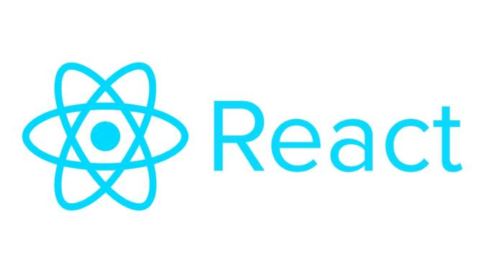
Figure 11. React
Source: https://repository-images.githubusercontent.com/37153337/9d0a6780-394a-11eb-9fd1-6296a684b124
React is an open-source JavaScript library designed for building user interfaces (UIs) and handling the view layer of web applications. Maintained and developed by Facebook, React enables developers to construct reusable UI components that efficiently updates and render data in response to changes. Its initial releases occurred in 2013, and since then, it has garnered immense popularity among the developer community.
Integrating React into the dermatology clinic management system (DCMS) web-based application can bring numerous advantages, as React is well-suited for building interactive and dynamic user interfaces. Using React's component-based architecture allows developers to break down the DCMS UI into reusable and modular components. This simplifies the development process, encourages code re-usability, and makes the application easier to maintain and scale. More than that, React's virtual DOM and efficient rendering mechanism enable real-time updates to the UI based on changes in the application's state. This is particularly useful in the DCMS, where patient data and appointments may be constantly updated.

2.2.6 Linux

Figure 12. Linux
Source: https://www.linux.org/
Linux is an open-source platform developed by consensus among a diverse community of developers around the globe. It has become the preferred choice due to its versatility and support for many different platforms. With its flexible adaptability, Linux can run on a wide range of devices, from personal computers to servers and embedded devices.
One of the key characteristics of Linux is its emphasis on security; it often receives high marks in terms of security, thanks in part to the developer community that is constantly working to find and fix security holes. This community is constantly improving security features and updating them to protect systems from potential threats.
It is for these reasons that our system has chosen to use Linux. Linux security is an important factor in ensuring the safety and good management of user information. This operating system provides us with peace of mind in efficiently and reliably managing user data and sensitive information.

2.2.7 NGINX
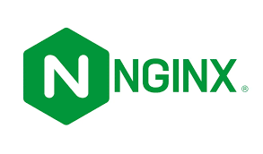
Figure 13.NGINX
NGINX is an open-source reverse proxy server and web server solution designed to efficiently handle and deliver HTTP and TCP requests across networks. Its combination of multitasking and impressive performance has made it a critical component of the infrastructure of many web applications and services globally.
In the context of our application, we use NGINX to perform many important functions. Firstly, we take advantage of its SSL security certificate configuration feature to ensure that the data transmitted through our web is encrypted and protected, creating a safe environment for users, and protecting sensitive data from potential threats.
Additionally, we use NGINX to configure and distribute domains to Docker containers, taking advantage of Docker's flexibility to deploy and manage applications easily and efficiently. Using NGINX as a middle layer helps to create a better distribution of responsibility and load balancing for our container applications.

2.2.8 Google Cloud
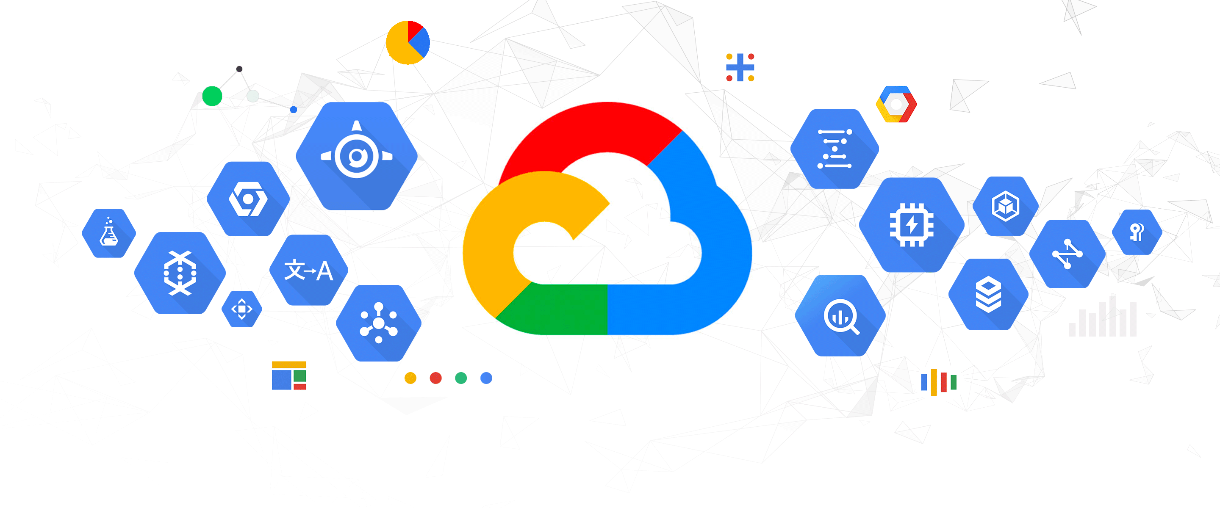
Figure 14.Google Cloud
Google Cloud is a system of cloud and cloud computing services provided by Google that provides businesses and individuals with a set of resources and services to deploy, manage, and develop their online applications and services easily, flexibly, and efficiently.
In the case of our application, we have chosen to use Google Cloud to implement an API of artificial intelligence (AI). Using Google Cloud allows us to easily deploy and manage APIs without having to worry much about the underlying infrastructure. We can focus on developing and improving aspects of AI applications without being limited by hardware or network management.

2.3 Android application

2.3.1 Axios 1.4.0

Figure 15. Axios
Source: https://assets-global.website-files.com/5e19ea5aa7d3a217492e372b/624de949df5a11680ab170b9_Axios%20logo%20-%20RGB%20-%20minimum%20space.png
Axios is a popular JavaScript library used for making HTTP requests from web browsers or Node.js applications. It acts as a promise-based HTTP client that allows you to perform asynchronous operations to interact with API and fetch data from servers.
Axios provides a simple and straightforward API, making it easy to send HTTP requests with various methods like GET, POST, PUT, DELETE, etc. It supports request and response interceptors, which can be used for tasks like adding headers, handling errors, or modifying data before it is sent or received. Additionally, Axios automatically parses JSON responses, simplifying the process of working with API data.
In the context of an Android application for the dermatology clinic management system (DCMS), Axios can be a valuable tool for making HTTP requests to communicate with back-end servers or API. Importantly, Axios can be used for JavaScript and react-native to handle system functions.

2.3.3 React Native 0.72
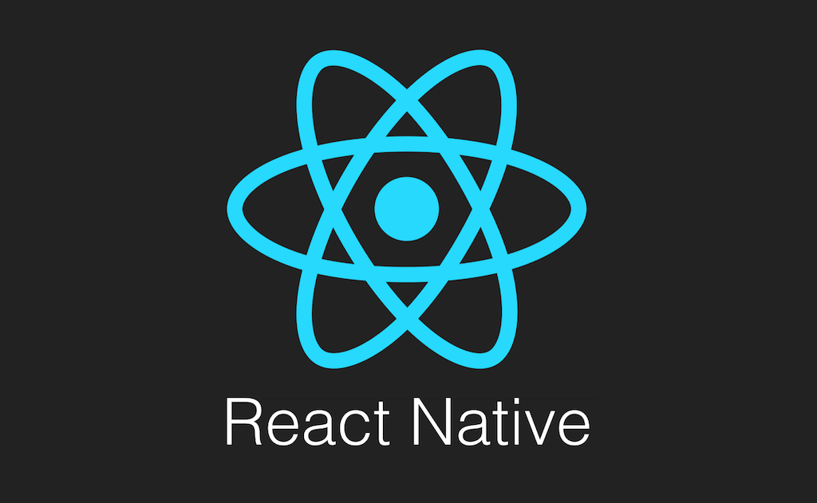
Figure 16. React native
Source: http://www.appcoda.com/wp-content/uploads/2015/04/react-native.png
React Native is an open-source mobile application framework created by Facebook. It empowers developers to build native mobile apps using JavaScript and React. This framework is widely favored for cross-platform app development, enabling the creation of mobile applications that can seamlessly run on both iOS and Android platforms. The beauty of React Native lies in its ability to share a considerable portion of the code base, making app development more efficient and reducing redundancy.
The incorporation of React Native into the dermatology clinic management system (DCMS) Android application offers various advantages, particularly in terms of cross-platform development and ensuring a consistent user interface experience. When using react native, you can use the cross-platform compatibility feature to be able to build and run applications on both iOS and Android operating systems for easy interface design and also flexibility when deploying applications.

3. Existing Systems

3.1 Doctor
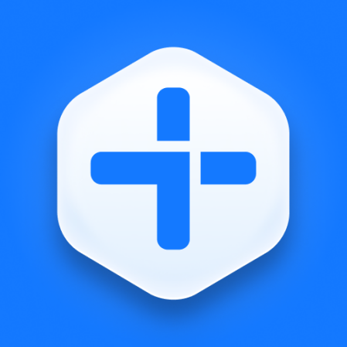
Figure 17. Edoctor
Source: https://play.google.com/store/apps/details?id=vn.edoctor.userapp&hl=vi
Founded in 2014, eDoctor is a technology company with the desire to build a comprehensive healthcare system through a mobile application. Currently, eDoctor has built a large user community and become a trusted partner by hundreds of businesses in Vietnam. Based on information technology platform, eDoctor application helps to connect users and doctors easily anytime, anywhere. Users can use the application to get health advice, look up drugs & clinics, and other health services. However, the application still has a limitation, does not provide a schedule function for new users and while using it, there are still some errors with account connection when logging in.
The link application: https://edoctor.io (Access date 21/9/2015).

3.2 PureSkin Laser Clinic

Figure 18. PureSkin Laser Clinic
Source: https://img.jamja.vn/jamja-prod/tmp_gcs_full_5d22c23876ec5741431a4f6e-2019-07-08-041033.jpeg?cache=1&w=150
With the mission of Regenerating youth for Vietnamese women, PureSkin Laser Clinic is a chain of high-tech skin care and treatment by a team of well-trained Doctors and Consultants.
- The mobile app enables PureSkin customers to:
- Make an appointment, change the appointment schedule more proactively
- Always be updated with the latest promotion news
- Conveniently track your points and transaction history
- Direct feedback on products as well as service quality at the spa
However, the application still has the limitation that it has not yet offered a facial scan function for AI to analyze skin conditions, so that doctors can support patients as best as possible.
The link application: https://pureskin.com.vn (Access date 21/9/2018).

3.3 MedPro

Figure 19. Medpro
Medpro is an Appointment Registration Software at Ho Chi Minh City Dermatology Hospital. This software helps patients and relatives of patients to register online for medical examination at the hospital anytime, anywhere without having to go to the hospital directly, including the following online utilities:
- Register and choose the date and time of the medical examination.
- Payment of medical expenses without cash.
- Manage medical appointments and follow-up visits.
- Manage patient information and data.
However, there is still a downside that does not support using AI face scanning to analyze facial skin, which makes it difficult for users to know their current skin condition.
The link application: https://dalieu.medpro.vn/ (Access date 11/10/2022).

3.4 VietSkin
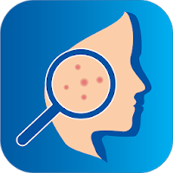
Figure 20. VietSkin
Source: https://cdn.tgdd.vn/2020/04/GameApp/image(13)-200x200-1.png
VietSkin is the first online dermatology consulting medical application in Vietnam, following the development trend of 4.0 technology. This app to connect with a dermatologist is as effective as a hospital visit.
- Consult dermatology, related diseases such as: Acne, dermatitis, shingles, langben, psoriasis, warts, ... online with a specialist, no need to wait in line.
- Chat and send photos and videos directly to the doctor to make the examination results more accurate and faster.
- Get an online prescription from your doctor right on the app, or you can order medicine online and receive it at home.
- Applying technology to help analyze skin by AI artificial intelligence: Diagnose skin health, analyze skin, suggest cosmetics suitable for the skin.
Although there are many good aspects, the application still cannot help users see their medical schedule and drug bill information so that they can easily review the information.
The link application: https://www.vietskin.vn/ (Access date 11/10/2022).

4. Business Opportunity
The Skinsense(dermatology clinic management system) presents a lucrative business opportunity as an Android and web-based application. By offering a comprehensive platform to streamline clinic operations, the DCMS enhances clinic efficiency, patient experience, and accuracy in record-keeping. Its user-friendly interface and integration with medical devices ensure a seamless workflow for healthcare professionals. With data analytic and insights, clinics can make informed decisions to optimize performance and revenue. Providing customization and scalable solutions caters to individual clinic needs, while cloud-based accessibility ensures easy maintenance and updates. As the healthcare industry embraces digital solutions, the demand for specialized clinic management systems grows, offering the potential for expanded market reach and revenue streams.
Compare Skinsense(dermatology clinic management system) application with other applications:
- Neatly designed interface makes it easier for users to access
- Can book and review already booked schedules.
- Can Scan AI detect acne and analyse facial skin condition.
- When examining will be able to update the bills on the application.
Name applications | Limitations
Edoctor | - No AI scan to assess facial skin condition.  - Appointments are not supported for new people, only old patient codes registered at the hospital can be used.  - Does not support the recommendation of dermatological health products.
PureSkin Laser Clinic | - No AI scan to assess facial skin condition.  - Does not support the recommendation of dermatological health products.  - Unfriendly design and difficult to use interface.
MedPro | - No AI scan to assess facial skin condition.  - Does not support the recommendation of dermatological health products.
Table 1. The table lists the limitations of the dermatology clinic application available on the market.

5. Software Product Vision
The purpose of the application is that it can be used in today's dermatology clinics and helps patients easily recognize their skin even at home. In terms of meaning, the app can give users the best experience when booking services and help users access to the best skin care practices, as well as understand their skin. Currently, the market has also launched a lot of products about dermatology clinics, but with our products, they are superior to them in terms of user experience.

6. Project Scope & Limitations

6.1 Major Features
FE-01: Book a medical appointment, select the treatment you need to use and choose a date and time to schedule an appointment.
FE-02: Using AI-integrated camera to analyze facial skin condition, patients can use the camera to capture their own face and AI will analyze facial skin condition.
FE-03: Doctors may agree or cancel a patient's appointment at their sole discretion.
FE-04: Patients can view their prescription history and medical appointments.
FE-05: Provide information about facial skin and skin care tips, information and news will be updated in the admin web management.
FE-06: The doctor will generate an invoice after prescribing the medicine.
FE-07: Each account can change their profile about basic information and update their avatar.
FE-08: Data management information of treatment.
FE-09: Data management information of prescription.
FE-10: Data management information of medical report.
FE-11: Data management information of dermatological disease.
FE-12: Data management information of specialist.
FE-13: Data management information of account.
FE-14: Data management information of role.
FE-15: Data management information of medical report.
FE-16: Data management information of invoice.
FE-17: Data management information of patient.
FE-18: Data management information of medication.

6.2 Limitations & Exclusions
LI-1: Our application can only register and login in the system not login with Google or Facebook account.
LI-2: Paying for dermatology products on the app, the current app can only suggest product information, cannot buy products.
LI-3: Live video call with doctors, currently can only text for advice.
LI-4: After the examination is complete, you can rate the number of stars for the doctor.

